

|  |  |
| --- | --- |
| **Name: Sayyed Sohail Rashid** | **Course Name: SMA-LAB** |
| **Class: BE-CO** | **Batch: 01** |
| **Roll no: 18CO48** | **Experiment No: 05** |

**Aim**: Develop Content (text, emoticons, image, audio, video) based social media analytics model for business.

**Code:**

# -*- coding: utf-8 -*-

!pip install snscrape

# Commented out IPython magic to ensure Python compatibility.

import pandas as pd

import snscrape.modules.twitter as sntwitter

import numpy as np

import matplotlib.pyplot as plt

import seaborn as sns

import nltk

nltk.download('stopwords')

from nltk.corpus import stopwords

from nltk.tokenize import word_tokenize

from nltk.stem import WordNetLemmatizer

from nltk.stem.porter import PorterStemmer

import string

import re

import textblob

from textblob import TextBlob

import os

from wordcloud import WordCloud, STOPWORDS

from wordcloud import ImageColorGenerator

import warnings

# %matplotlib inline

os.system("snscrape --jsonl --max-results 5000 --since 2023-01-31 twitter-search 'Unilever 2023 until:2023-02-07'>text-query-tweets.json")

tweets_df = pd.read_json("text-query-tweets.json" ,lines=True)

tweets_df.tail(5)

tweets_df.to_csv()

df1 = tweets_df[[ 'date', 'rawContent' , 'renderedContent' , 'user' , 'replyCount' ,'retweetCount' , 'likeCount' , 'lang' , 'place']]

df1.head()

plt.figure(figsize=(17, 5))

sns.heatmap(df1.isnull(), cbar=True, yticklabels=False)

plt.xlabel("Column_Name", size=14, weight="bold")

plt.title("Places of missing values in column",size=17)

plt.show()

import plotly.graph_objects as go

Top_Location_Of_tweet= df1['place'].value_counts().head (10)

print(Top_Location_Of_tweet)

from nltk. corpus import stopwords

stop = stopwords.words('english')

df1['renderedContent'].apply(lambda x: [item for item in x if item not in stop])

df1.shape

!pip install tweet-preprocessor

#Remove unnecessary characters

punct = ['%','/',':','\\','&amp','&',';','?']

def remove_punctuations(text):

  for punctuation in punct:

    text = text.replace(punctuation,'')

  return text

df1['renderedContent'] = df1['renderedContent'].apply(lambda x: remove_punctuations(x))

df1['renderedContent'].replace( '', np.nan, inplace=True)

df1.dropna(subset=["renderedContent"],inplace=True)

len(df1)

df1 = df1.reset_index(drop=True)

df1.head()

from sklearn.feature_extraction. text import TfidfVectorizer, CountVectorizer

# Commented out IPython magic to ensure Python compatibility.

sns.set_style('whitegrid')

# %matplotlib inline

stop=stop+['assured' , 'health' , 'http' , '2023', 'best' ,'look' , 'union', 'product' , 'customer' , 'india']

def plot_20_most_common_words(count_data, count_vectorizer) :

  import matplotlib. pyplot as plt

  words = count_vectorizer.get_feature_names()

  total_counts = np. zeros(len(words))

  for t in count_data:

    total_counts = t.toarray()[0]

  count_dict = (zip(words, total_counts))

  count_dict = sorted(count_dict, key=lambda x:x[1],reverse=True)[0:20]

  words = [w[0] for w in count_dict]

  counts = [w[1] for w in count_dict]

  x_pos = np.arange(len(words))

  plt.figure(2, (40,40))

  plt.subplot(title = '20 most common words')

  sns. set_context('notebook',font_scale=4,rc={ 'lines.linewidth' :2.5})

  sns.barplot(x_pos, counts, palette='husl')

  plt.xticks(x_pos, words, rotation=90)

  plt.xlabel('words')

  plt.ylabel('counts')

  plt.show()

count_vectorizer = CountVectorizer(stop_words=stop)

# Fit and transform the processed titles

count_data = count_vectorizer.fit_transform(df1['renderedContent'])

# print(count_vectorizer)

# print(count_data)

# Visualise the 20 most common words

plot_20_most_common_words(count_data,count_vectorizer)

plt.savefig( 'saved_figure.png')

import cufflinks as cf

cf.go_offline()

cf.set_config_file(offline=False, world_readable=True)

def get_top_n_bigram(corpus, n=None) :

  vec = CountVectorizer(ngram_range=(2, 4), stop_words="english").fit(corpus)

  bag_of_words = vec.transform(corpus)

  sum_words = bag_of_words.sum(axis=0)

  words_freq =[(word, sum_words[0, idx]) for word, idx in vec.vocabulary_.items()]

  words_freq =sorted(words_freq, key = lambda x: x[1], reverse=True)

  return words_freq[:n]

common_words = get_top_n_bigram(df1['renderedContent'] , 8)

mydict={}

for word, freq in common_words:

  bigram_df = pd.DataFrame(common_words,columns = ['ngram', 'count'])

bigram_df.groupby( 'ngram' ).sum()['count'].sort_values(ascending=False).sort_values().plot.barh(title = 'Top 8 bigrams',color='orange')

def get_subjectivity(text):

  return TextBlob(text).sentiment.subjectivity

def get_polarity(text):

  return TextBlob(text).sentiment.polarity

df1['subjectivity']=df1[ 'renderedContent'].apply(get_subjectivity)

df1[ 'polarity' ]=df1[ 'renderedContent'].apply(get_polarity)

df1.head()

df1['textblob_score'] =df1[ 'renderedContent'].apply(lambda x: TextBlob(x).sentiment.polarity)

neutral_threshold=0.05

df1['textblob_sentiment']=df1[ 'textblob_score']

textblob_df = df1[['renderedContent','textblob_sentiment','likeCount']]

textblob_df["textblob_sentiment"].value_counts()

df_positive=textblob_df[textblob_df['textblob_sentiment']=='positive' ]

df_very_positive=df_positive[df_positive['likeCount']>0]

df_negative=textblob_df[textblob_df['textblob_sentiment']=='Negative' ]

df_neutral=textblob_df[textblob_df['textblob_sentiment']=='Neutral' ]

#Creating the text variable

positive_tw ="Social,Media,Analytics,Calculation,productivity,financially,physically,emotionally,socially,privacy,Brief,Method,Texts,Analysis"

# Creating word _ cloud with text as argument in . generate() rtpthod

word_cloud1 = WordCloud(collocations = False, background_color = 'white') .generate(positive_tw)

# Display the generated Word Cloud

plt. imshow(word_cloud1, interpolation='bilinear')

plt.axis('off')

plt.show()

#Creating the text variable

negative_tw ="productivity,financially,physically,emotionally,socially,privacy,neutrality,algorithms ,Social,Media,Analytics,Calculation, "

# Creating word _ cloud with text as argument in . generate() rtpthod

word_cloud2 = WordCloud(collocations = False, background_color = 'white') .generate(negative_tw)

# Display the generated Word Cloud

plt. imshow(word_cloud2, interpolation='bilinear')

plt.axis('off')

plt.show()

#Creating the text variable

neutral_tw ="neutrality,algorithms ,Social,Media,Analytics,Calculation,productivity,financially,physically"

# Creating word _ cloud with text as argument in . generate() rtpthod

word_cloud2 = WordCloud(collocations = False, background_color = 'white') .generate(neutral_tw)

# Display the generated Word Cloud

plt. imshow(word_cloud2, interpolation='bilinear')

plt.axis('off')

plt.show()

**Output:**

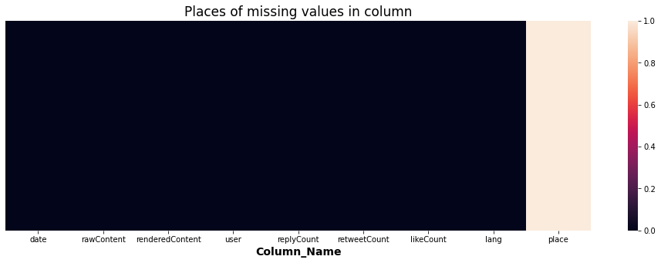

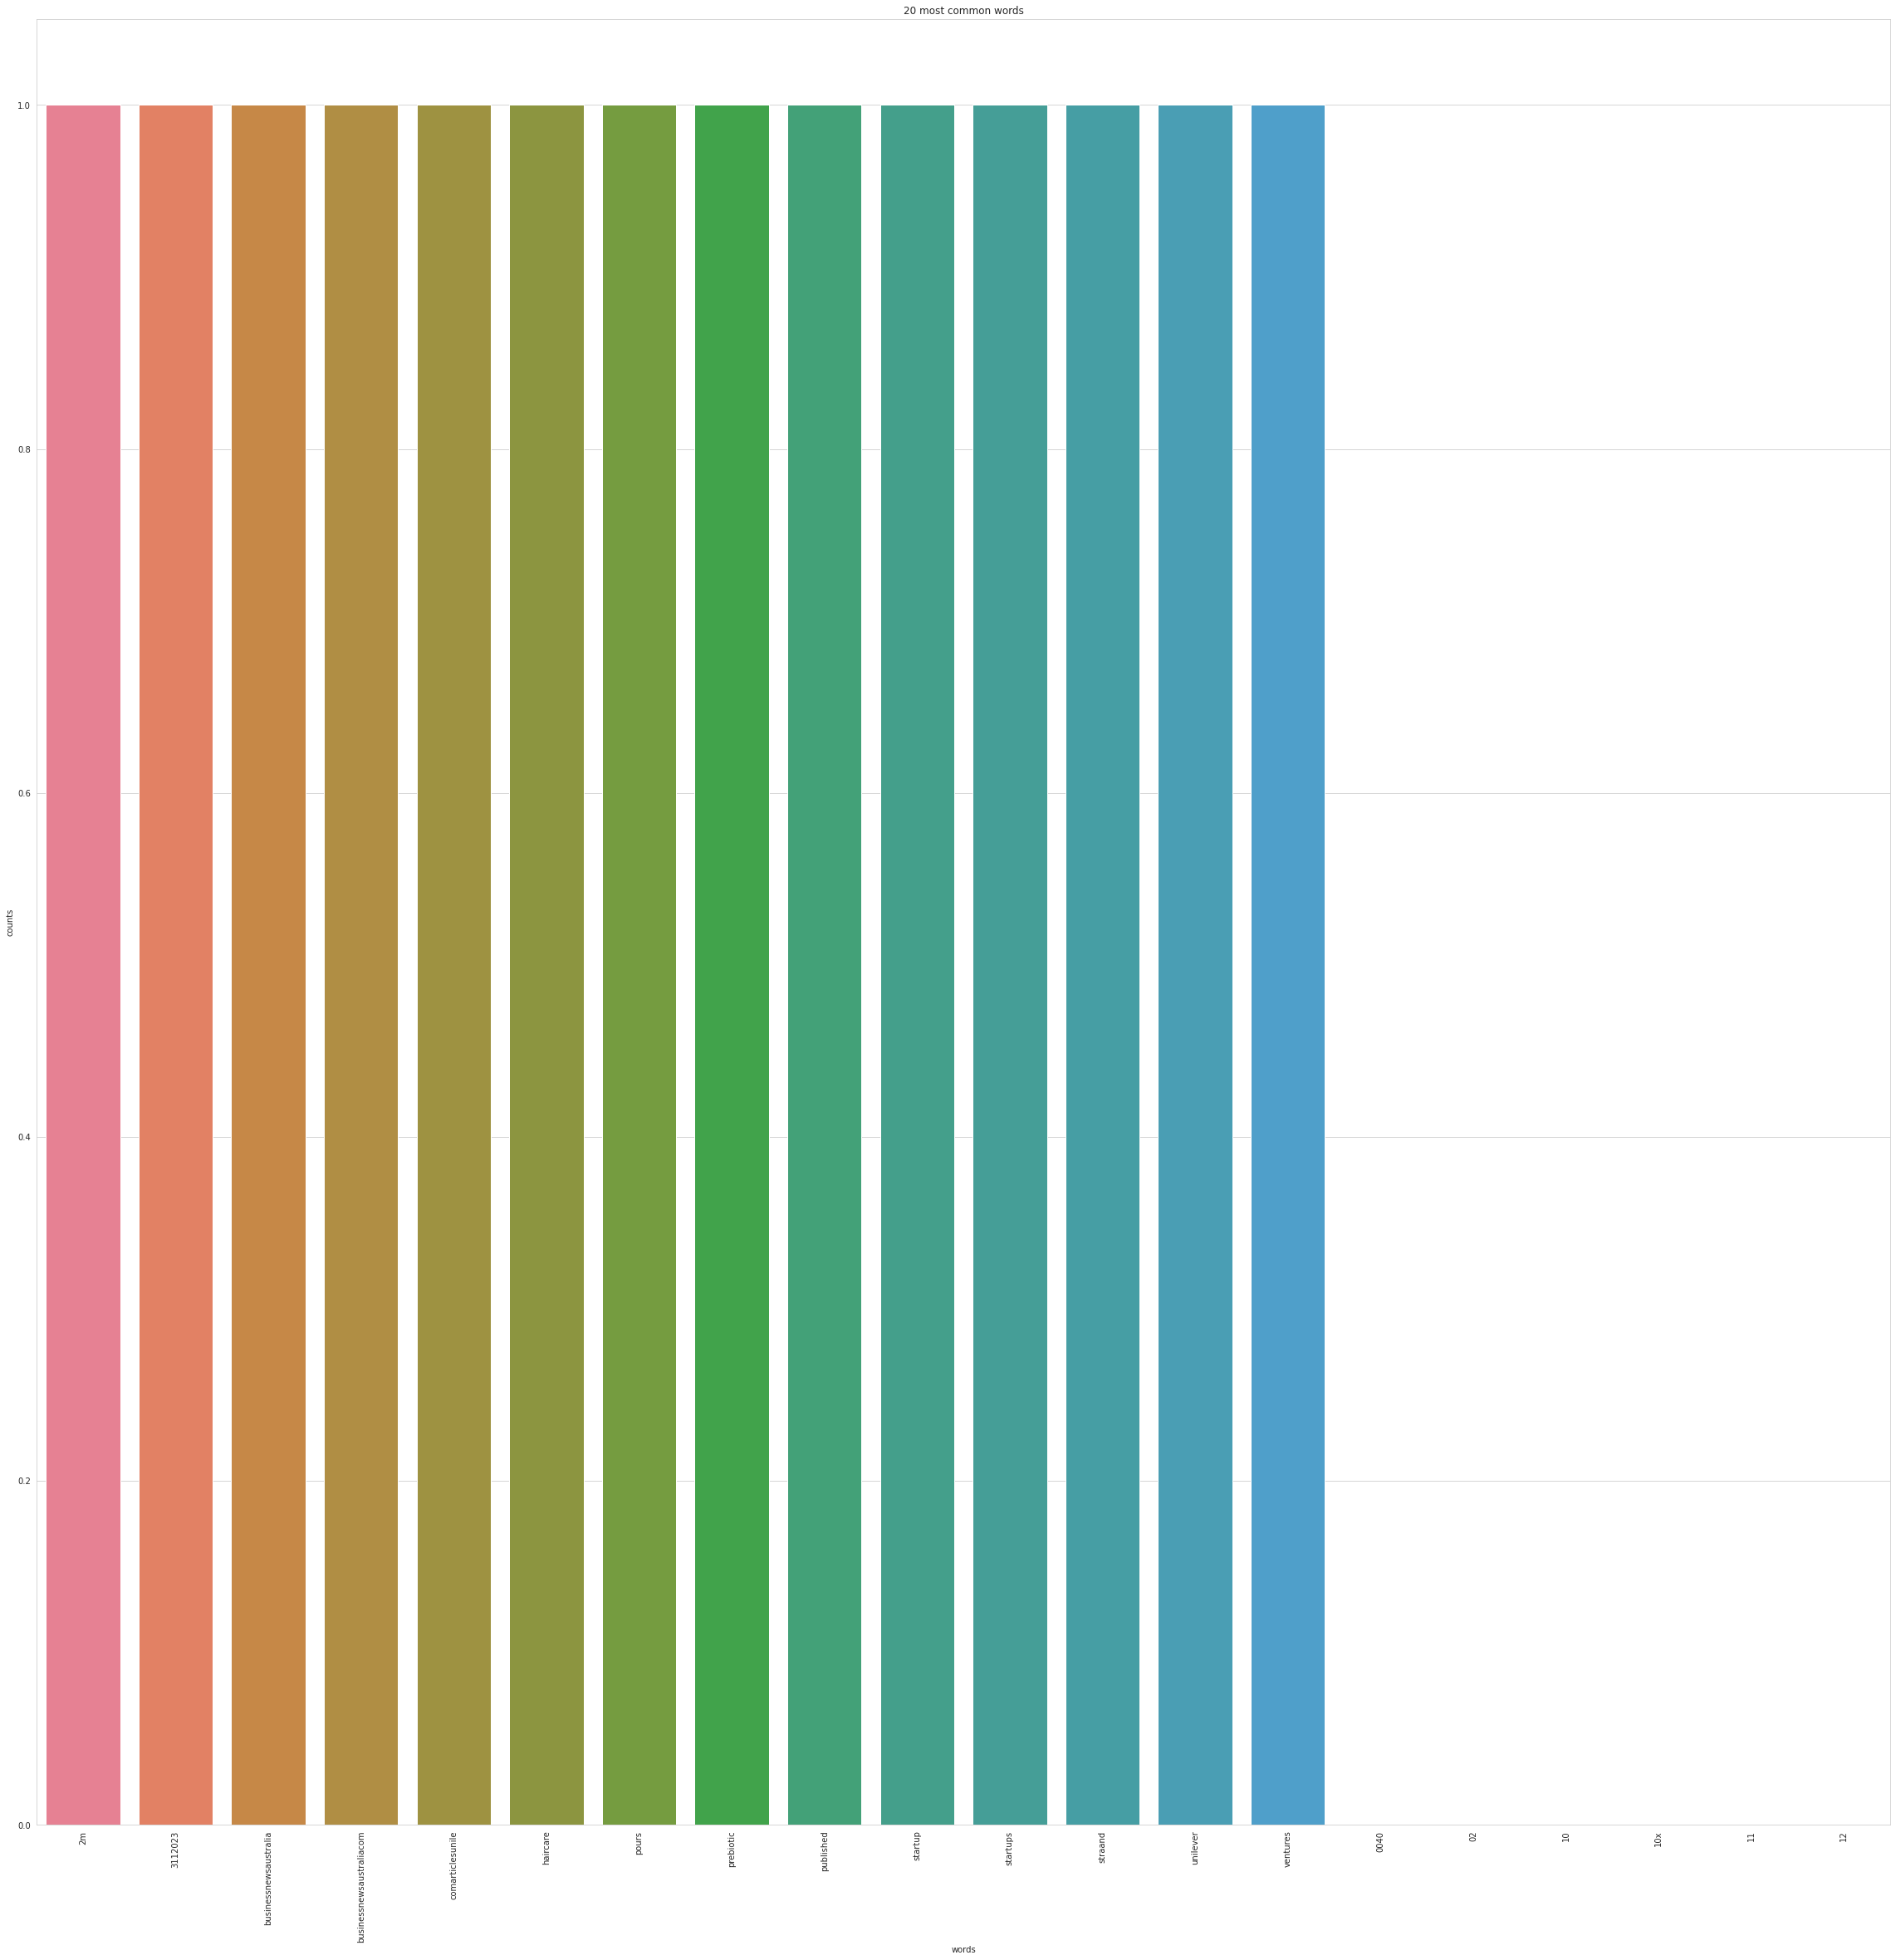

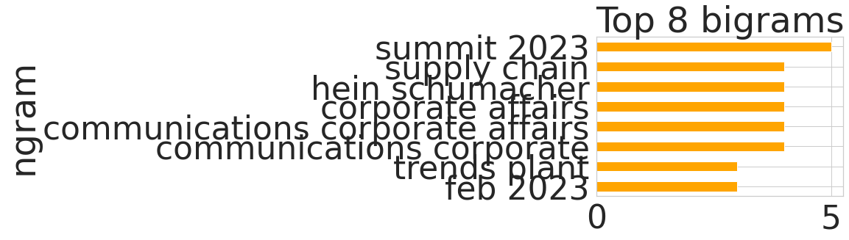

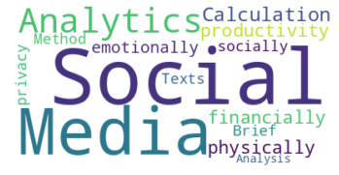

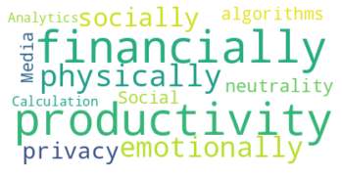

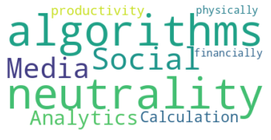

**Conclusion:**  We have successfully created content based social media analytics model for business.